SQL PROJECT
G.V.S Sai Ram (BK 02)
Scenario: Hospital Management System Database
You are responsible for designing a database management system for a medium-sized hospital. The hospital requires a system to manage patient records, appointments, medical staff information, billing, and medical history.
→ How to create database
Syntax: Create database data base name;
Create database medium_ hospital_ managemet;
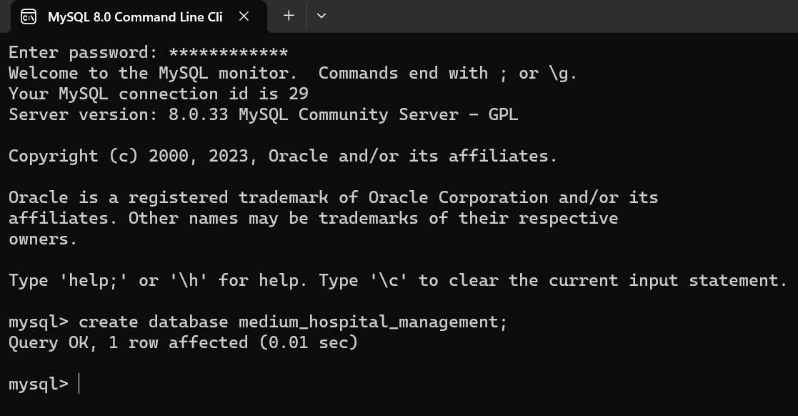
Questions:
1. Patient Information : How would you organize the patient information in the database? What data would you store for each patient? 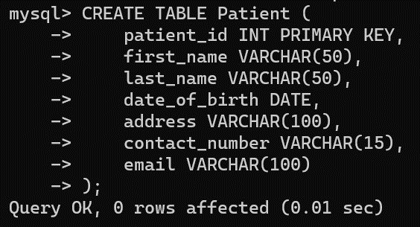
- Inserting the values into above patient table:
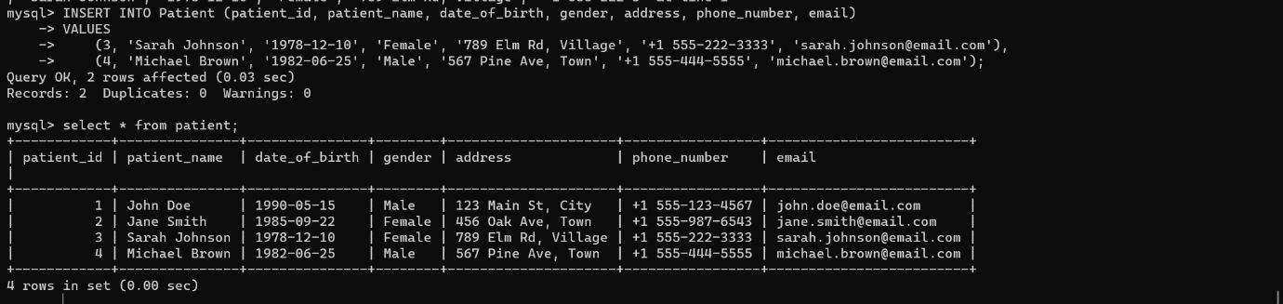
2. Doctor Details :
Create a table to store information about doctors. What attribute would you include table ?
Syntax : Create table table name;
Insert inti table name values;
Attributes : doctor_id, firstname, last_name, contact_number, emial
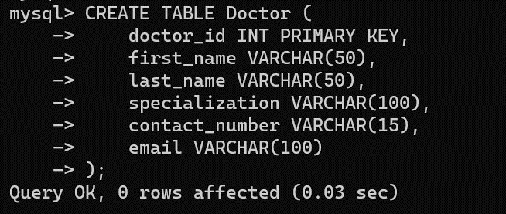
- Inserting into values in above table
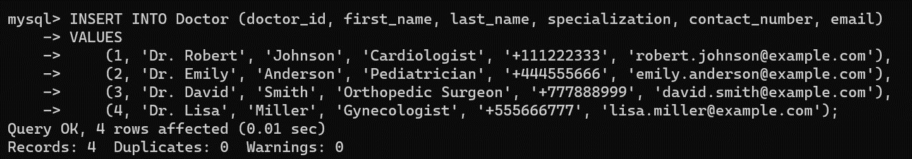
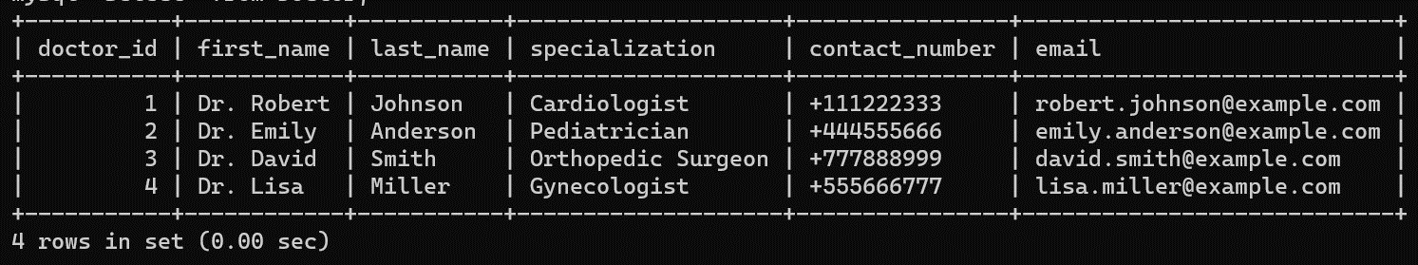
3. Appointment Management :
Describe how you would track patient appointments with doctors in the database?
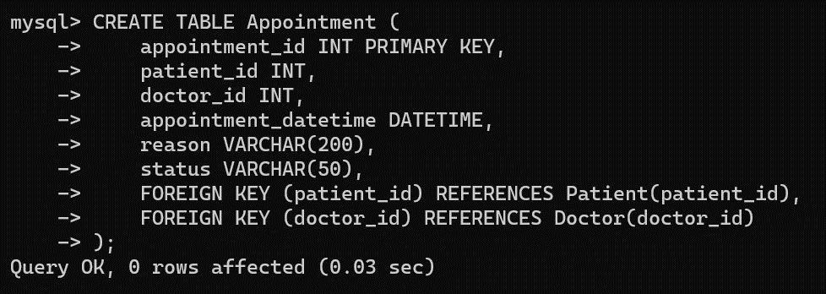
- Inserting into values in above table

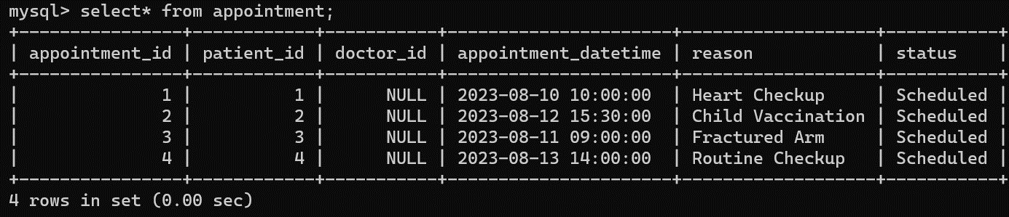
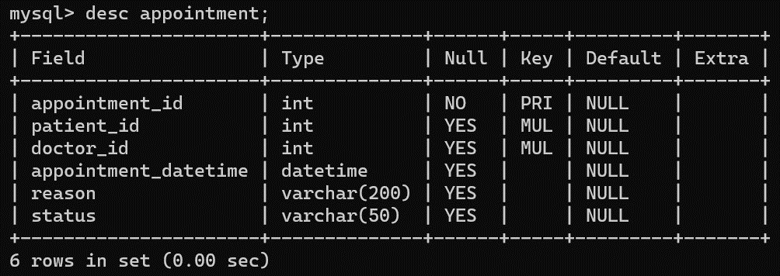
Syntax : select * from patient as p join appointment as a on p.patient_id= a.patient_id join medicalstaff as m on m.staff_id=a.staff_id;
4.Medical Tests :
How would you manage the information about various medical tests offered by the hospital?

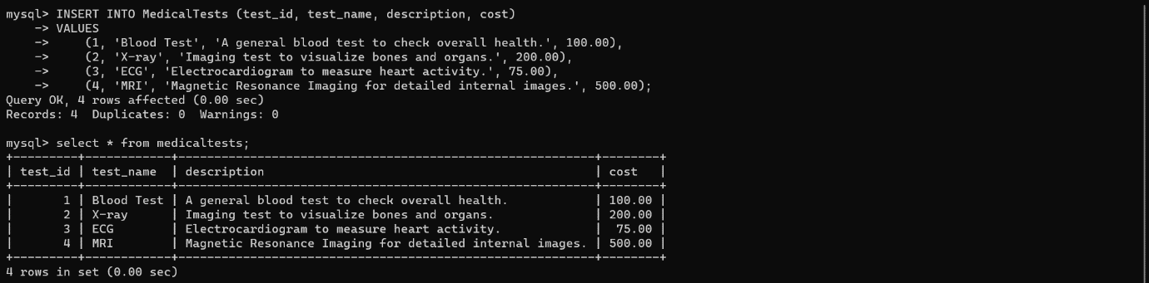
5. Doctors Weekly Schedule :
How would you store and display the weekly schedule for a specific doctor , showing the appointments with patients for each day ?
Syntax : select * from doctor_w_s where d_id=1;


THANK YOU

